Template for the 2nd International Workshop on Sediment Bypass Tunnels 2017
Sohei Kobayashi, Christian Auel and Tetsuya Sumi
Abstract
In order to ensure uniform style throughout the volume, all the papers have to be prepared strictly according to the instructions set below. For the convenience of the authors, template files for MS Word 6.0 (and higher) are provided.
Keywords: up to 5

General instructions
The authors are kindly asked to create their technical paper/extended abstract in Microsoft Word-Format (*.doc or *.docx) using the present template and following the guidelines. The complete contribution should not exceed 8 pages including figures, references and addresses of the authors. Do not number the pages. This will be done by the publisher as soon as all contributions will have been submitted.
Please submit the technical paper as a Word file by 18th of March 2017 to kyoto.ecohydro@gmail.com.

Content
The foci of this workshop are the following topics:
A Upstream Aspects
A.1 Hydrology
A.2 Sediment Erosion & Inflow
B Tunnel
B.1 Hydraulics & Sediment Transport
B.2 Planning & Design
B.3 Tunnel & Inlet Works
B.4 Invert Abrasion
B.5 Maintenance
C Downstream Aspects
C.1 Morphological Changes
C.2 Ecological Effects
D Operation
D.1 Monitoring & Instrumentation
D.2 Real-time Operation
The authors are kindly requested to cover these issues as far as possible. If the author presents a sediment bypass tunnel, he is kindly asked to include figures of the cross section, plan view and profile. Obviously, additional site specific experiences and subjects of interest are welcome.

Layout

Type font, size and spacing
Use Times New Roman 12 pt size with 1.2 line spacing (Text style: Normal text). For tables (Text style: Table), table captions (Text style: Table Caption), figure captions (Text style: Figure Caption) and references (Text style: Reference) use 10 pt.
The paragraphs are justified one column. The spaces between paragraphs and titles are generally 6 point.
The margins at all four sides of the page are 3 cm. Please do not insert additional header or footer and do not use letter spacing or more than one space after each other.

Title and author(s)
The title font of the contribution is Arial 20 pt. The text is center justified, bold and maximum 3 rows (Text style: Title).
The authors are listed underneath the title. The font is justified, 12 pt and bold (Text Style: Author).

Headings
Primary headings are typed in Times New Roman 14 pt, bold and left justified. The space above and beneath this heading is 12 and 6 pt (Text style: Heading 1), respectively.
Secondary headings are typed in Times New Roman 13 pt, bold and left justified. The space above and beneath this heading is 9 and 6 pt (Text style: Heading 2), respectively.

Variables and equations
The font of mathematical variables (Q, h) in the text as well as in formulas is Times New Roman, the size is 12 point and italic. Use roman type except for parameters in mathematics (not for log, sin, cos, ln, max., d (in dx), etc.) and the titles of journals and books which should all be in italics. Beneath the first appearance, the variables should be defined.
To emphasize equations, they are shifted 1 cm to the right (Text style: Equation).
[1]

Lists
Please use text style „Lists“ for lists, as shown beneath:
- Water
- Fire
- Earth

Figures and tables
Number figures consecutively in the order in which reference is made to them in the text. Do not distinguish between diagrams and photographs.
The figure caption is placed below the figure and its font is Times New Roman 10 pt (Text style: Figure Caption). The space above and beneath figures is 12 and 6 pt (Text style: Figure), for captions the spaces are 6 above and 12 pt beneath (Text style: Figure Caption), respectively.
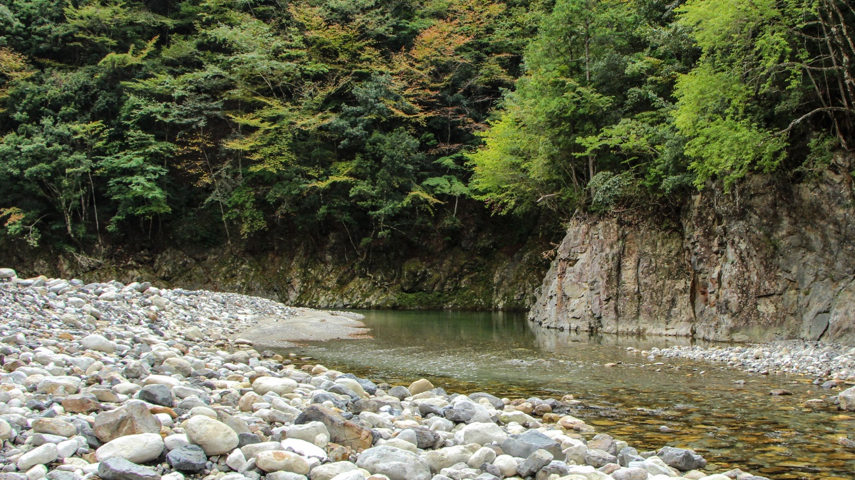
Abb. 1: Picture of Asahi River
Tables are labeled above in Times New Roman 10 pt font (Text style: Table Caption).
Tab. 1: Table of tested parameter combinations
Test | S | F | h | U | D | θ
 | [-] | [-] | [mm] | [m/s] | [mm] | [-]
TS1 | 0.01 | 1.5 | 50 | 1.13 | 5.4 | 0.039
TS2 | 0.01 | 2.0 | 50 | 1.27 | 5.4 | 0.046
TS3 | 0.01 | 2.5 | 50 | 1.43 | 5.4 | 0.057

Conclusions
In case of any problems with the template or hints, please do not hesitate to contact the organization committee via kyoto.ecohydro@gmail.com
Acknowledgement
Many thanks to all sponsors for their financial support and all authors for their contribution to this workshop. Text style of this heading is “Acknowledgement”.
References
Last name, First name initials (Year). Title of article. Title of Journal, volume number (issue number if necessary): page numbers.
Boes, R.M., Minor, H.-E. (2002). Hydraulic Design of Stepped Spillways for RCC Dams. Hydropower & Dams, 9(3), 87-91.
Last name, First name initials (ed.) (Year). Book title, Publisher, City, Edition.
Hager, W.H. (1999). Wastewater hydraulics, Springer: Berlin, New York, 2nd ed. 2010.

References are listed alphabetically and typed in font Times New Roman, size 10 pt (Text Style: Reference). In the text the reference is made by the authors’ last names (without initials) and the year of publication in parentheses. As an example Boes and Minor (2002) or Hager (1999) published…
If there is more than two authors, the reference changes to Boes et al. (2002).
Authors (Text style: AuthorsAdress)
Sohei Kobayashi (corresponding Author)
Christian Auel
Tetsuya Sumi
Water Resources Research Center, Disaster Prevention Research Institute, Kyoto University, Japan
Email: kyoto.ecohydro@gmail.com

(Text style: AuthorDescription)

